[Proposal Title]

Proposal prepared for:
Research Division
Mississippi DOT (MDOT)
Jackson, Mississippi

Prepared by:
[Consultant]

[Date]

1. Research Project Title
[Research Project Title]
2. Problem Statement and Research Objectives
[Text]
3. Research Plan
Task C1. The Consultant shall... [text]
Task C2. The Consultant shall... [text]
Task M1. The MDOT Research Division will... [text]
Task C3. The Consultant shall... [text]
4. Funding

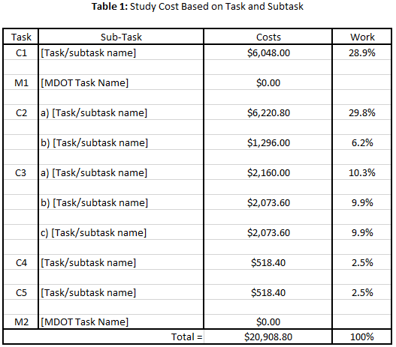
(Screenshot inserted from provided template)

5. Duration

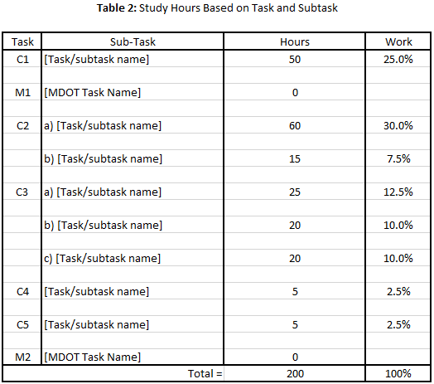
(Screenshot inserted from provided template)

Table 3. Gantt Chart Schedule

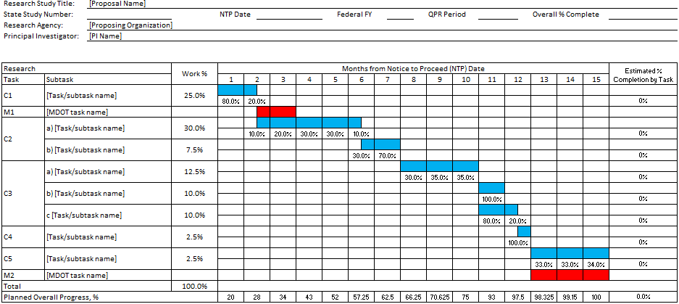

(Screenshot inserted from provided template)

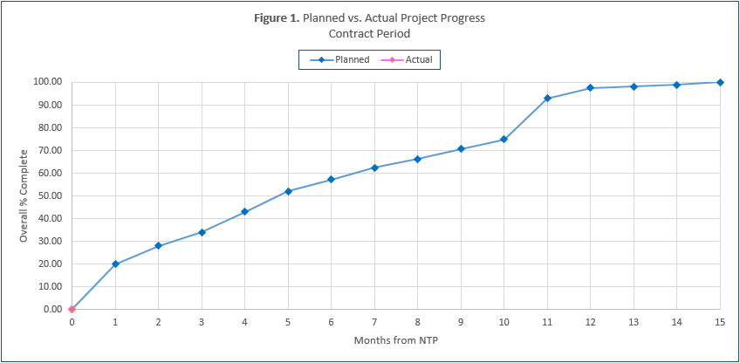

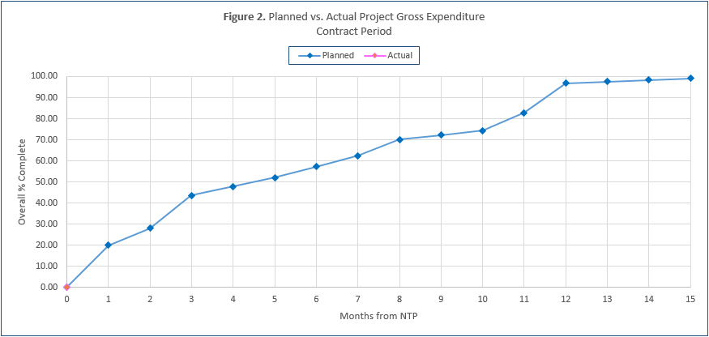
6. Anticipated Research Result
Detailed description of the anticipated product
[Text]
Benefits to MDOT facilities or services
[Text]
Implementation plan
[Text]
7. Summary
[Text]
8. MDOT Research Study TAC Members
[Name] has agreed to serve on the TAC and/or provide MDOT services in support of the study:
Name:
Title:
MDOT Division:
Work address:
City, State, Zip:
Phone:
Email:
9. Research Proposal Submitted By
Name:
Title:
Organization:
Address:
City, State, Zip:
Phone:
Email:
The Consultant affirms that he/she has reviewed and understands the requirements included in the version of this document corresponding to the Federal Fiscal year for which proposal funding consideration is requested. Such affirmation is evidenced by the following signature:

_______________________________________ _____________
Signature Date
10. Qualifications and Experience of Principal Investigators

[Name 1]
Experience and accomplishments
[Text]
Publications
- [List]
Professional Preparation
- [List]

[Name 2]
Experience and accomplishments
[Text]
Publications
- [List]
Professional Preparation
- [List]
11. Testing Facilities and Technician Experience
Include if applicable; see Appendix C of the MDOT Research Consultant Manual, online at http://mdot.ms.gov/portal/research.aspx

