SQS Worksheet generator
User Walkthrough

Table of Contents
Example of Worksheet Replicating 2
Step 1: Logging Into the System 2
Step 2: Create New Worksheet 3
Step 3: Adding Pay Items 4
Step 4: Editing Pay Item Information 8
Preliminary Column 8
Category Column 9
“OR After” Column 9
Pay Item Column 10
Supplemental Description Column 10
Step 5: Adding Comments 11
Add Comment 11
Altering Comments 12
Deleting Comments 12
Step 6: Associating Second Project to Worksheet 12
Step 7: Enter Information for Second Project 13
Step 8: Unlocking and Submitting the Worksheet 13
Step 9: Generating the Worksheet 14
Step 10: Revising Worksheet 16
Step 11: Create New Revision 17
Step 12: Revising Items 17
Step 13: Adding Reason for Revision 19
Adding Revision Reason 19
Altering Revisions 19
Deleting Revision 19
Step 14: Finalizing Worksheet 20

This will walk you through the process of creating an SQS Worksheet from start to finish for a worksheet that contains two separate projects. The worksheet that I am going to walkthrough is for project 107139-309000/107139-309100. It will be as follows:

Example of Worksheet Replicating
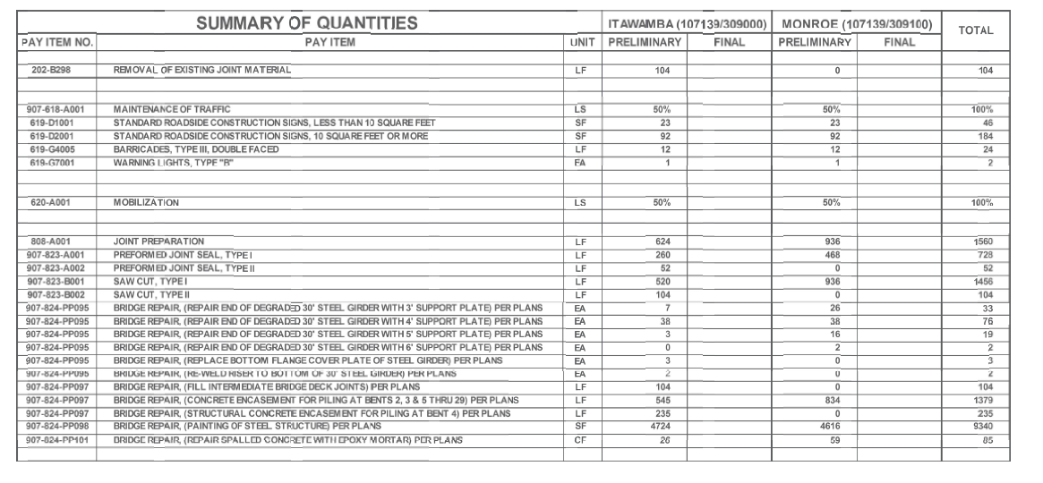

Step 1: Logging Into the System
When the login screen displays, enter your username and password for your MDOT account

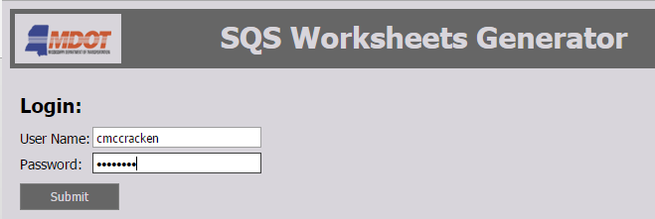

Once submitted your personal home page will display. If there are any active projects that you currently have locked out and are working on they will display on this page.
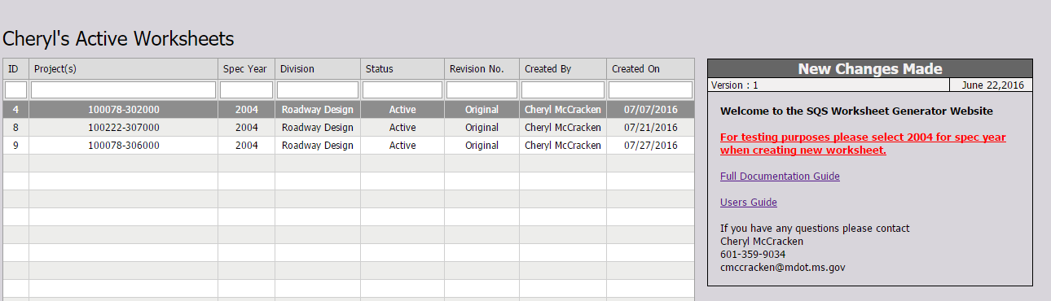

Step 2: Create New Worksheet
To create a new worksheet, select SQS Worksheet in the Menu Bar and select “Active Worksheets” for your division
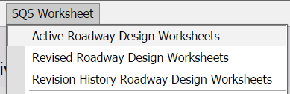

This page will display all active worksheets that you have access to.
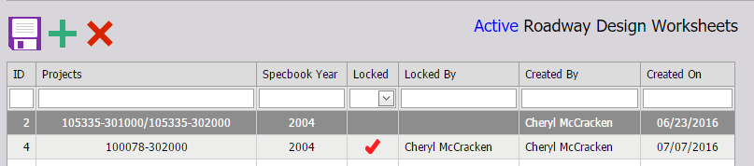
To create a new worksheet press the “Add” button 

This will bring up a list of projects that you have been given access to by your administrator.
If you do not see the project you have chosen to work on then you need to cancel and contact your admin before continuing. Otherwise, select the project and press “Select Project” at the bottom of the popup.

In this example we will do project 107139-309000

Because this is a new worksheet, when the pay item staging area loads for the first time you will prompted to select a Spec Year. This will determine which pay items you will have access to for that project.
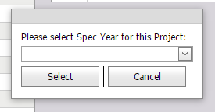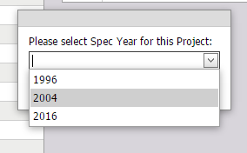

In this case we will select 2004 and press Select.

The staging area is now set and work can begin
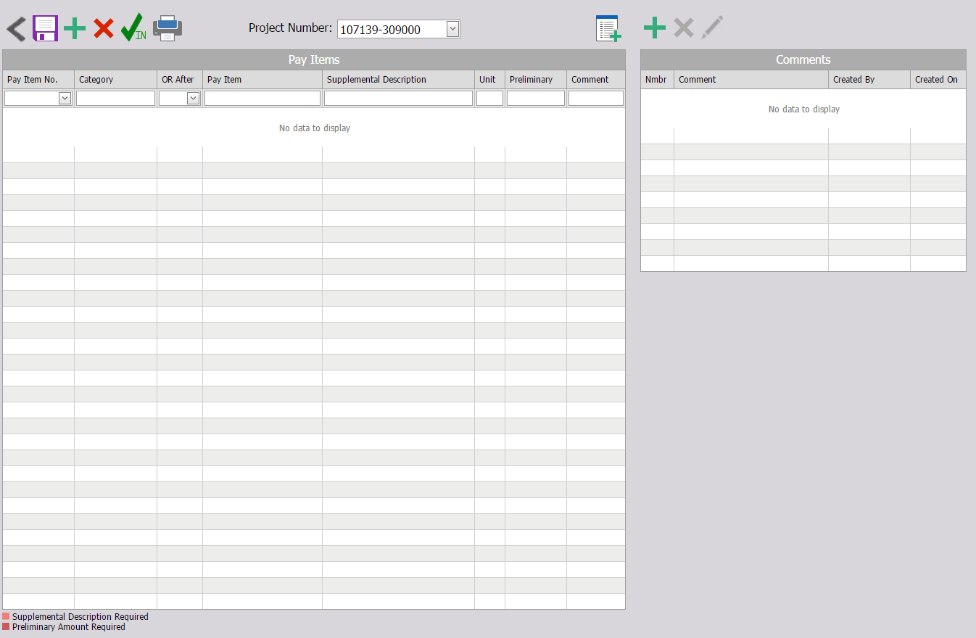

Step 3: Adding Pay Items
Now the process begins of adding needed Pay Items to the worksheet. To add a new pay item press the “Add” button.  A list of Pay Items associated with Spec Year 2004 will display.
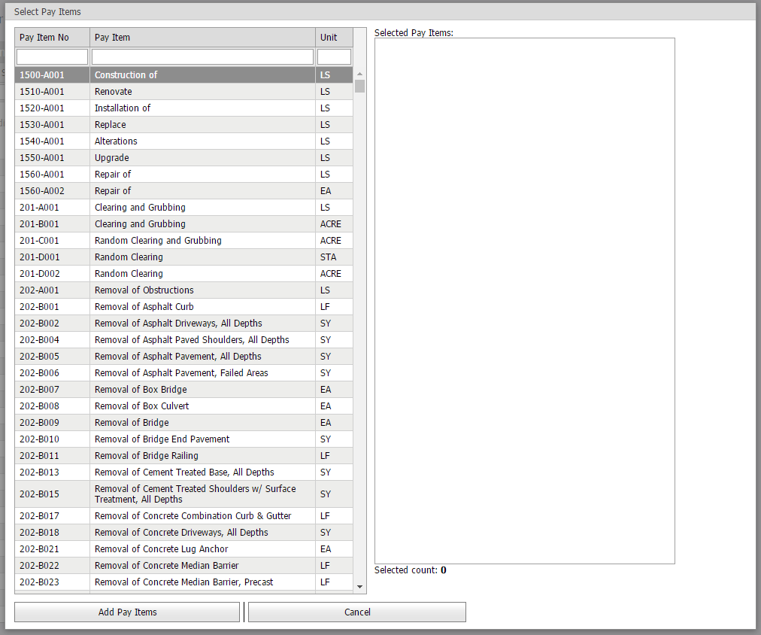
Pay Items can be located in this list using the filtering system.

In this case I am adding 202-B298. I type 202 into the filter bar and the results narrow down to all items that contain 202.
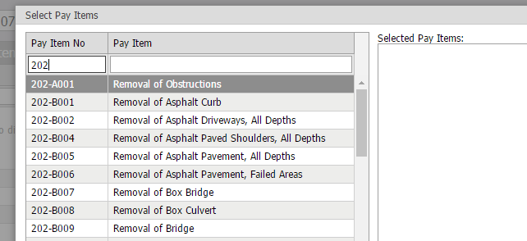
Now I scroll down until I find 202-B298 and double click to add it to the Selected Pay Items List on the right.
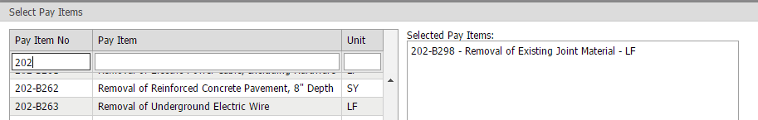

Next I will add 907-618-A001. I filter my results down to 907-618 items.
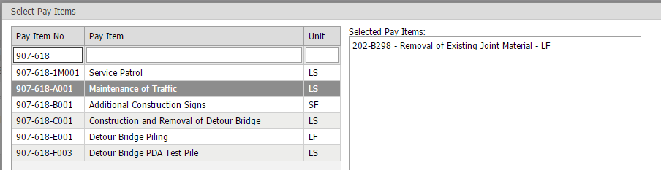

Then find A001 and add it to the list.
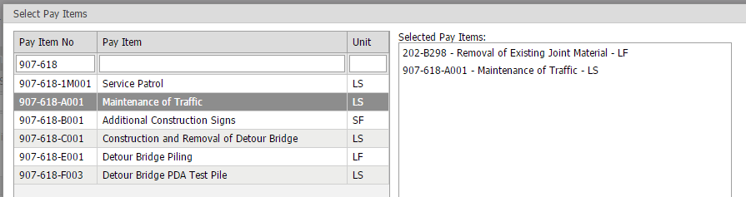
If I run into an issue where I added a pay item to the Select Pay Items list but have decided I do not need that pay item added to my worksheet, I can simply double click on that item in the Selected Pay Item list and it will be removed from the list.

Now, I run into an issue further into the worksheet where I have repeated items
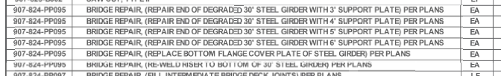

I will add 6 items with the same Pay Item Number of 907-824-PP095 to the Select Items List.
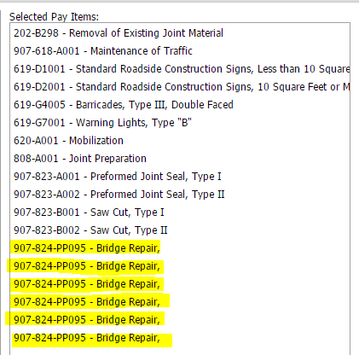

I then run into another issue further towards the bottom where there are two items that do not appear in my pay item list when I filter my items.
This leads me to believe that these items have either been marked as obsolete or contain a different spec year than that of what I selected for my worksheet. At this time I would check to make sure that is the case by contacting an admin.

I will continue this process until all my items have been added to the Select Pay Items List. I have added 21 items to my list.
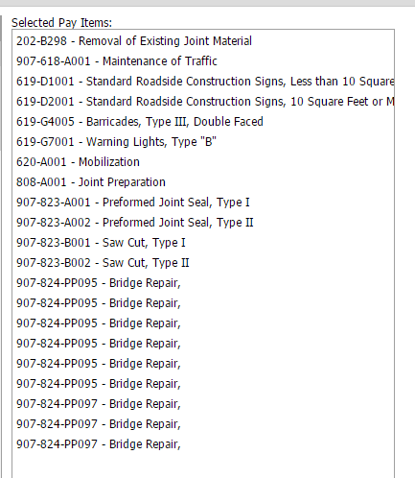

Now that all my items have been added to the Selected Pay Items list I can add them to the worksheet by selecting “Add Items” at the bottom of the popup. The popup disappears and the items appear in the worksheet.
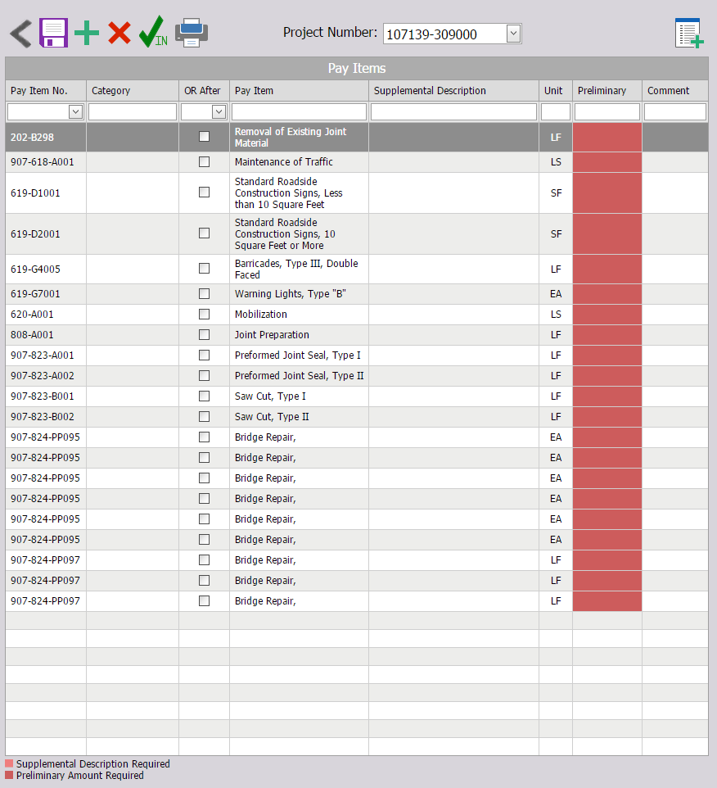

Step 4: Editing Pay Item Information
Now that all my pay items have been added to the worksheet I want to go in and alter/add information as needed.

Preliminary Column
This column is highlighted so inform you that this is a required field and has to be populated.
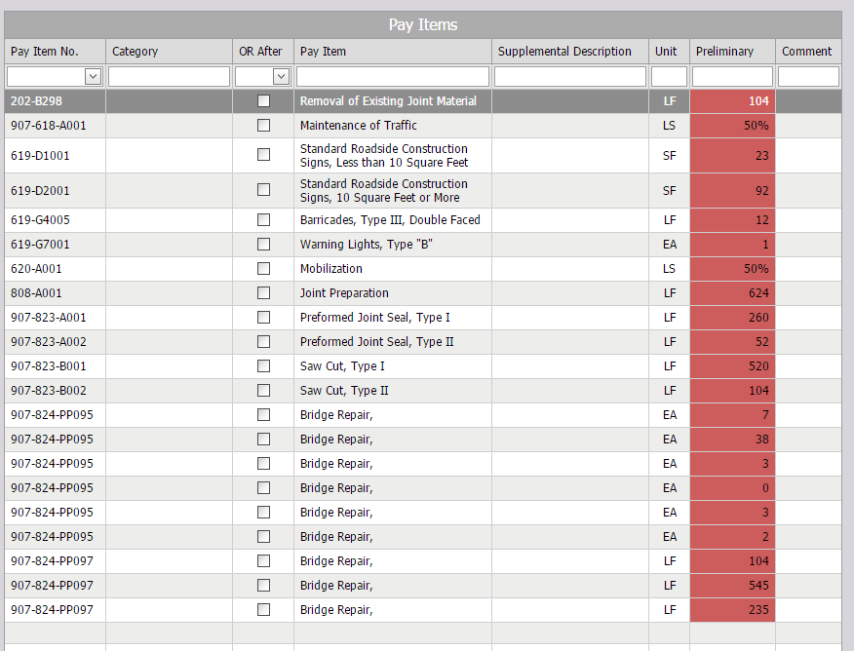
Now I will hit save to submit these changes.  The column goes from being a redish color to being back to the normal line coloring.
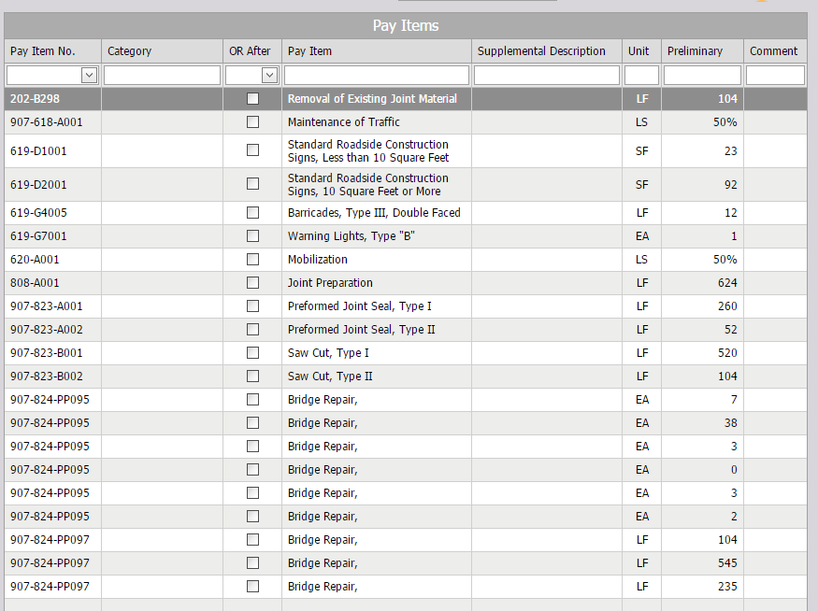

Category Column
This category allows like items to be grouped together on the worksheet.
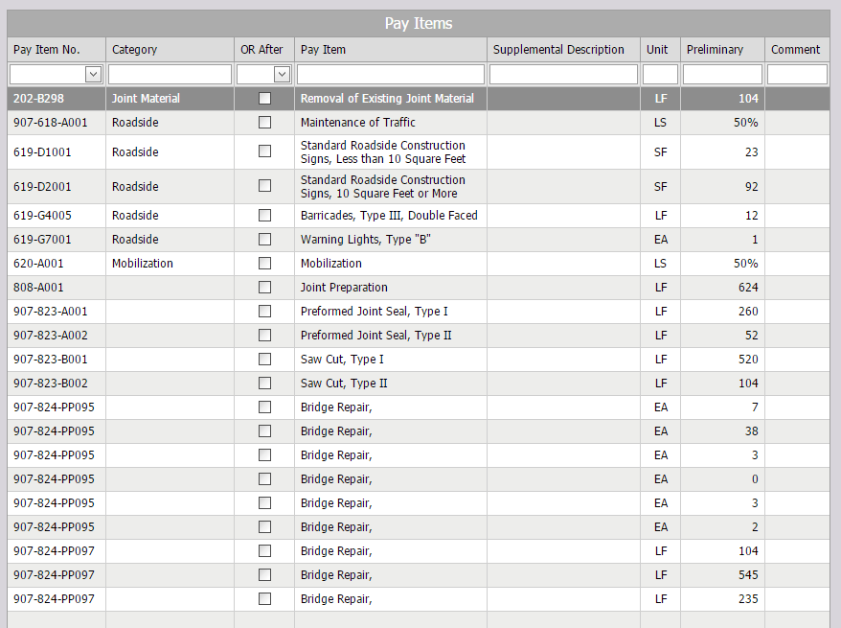
In this case, since all the final items are grouped together I can leave their category blank.

“OR After” Column
If there were “Or” statements that existed in this worksheet we would check the box under “OR After” for each item that would contain an “OR”.

For example if the worksheet showed

907-823-A001
907-823-A002

OR

907-823-B001
907-823-B002

I would check “OR After” in the row next to 907-823-A002 to indicate I wanted an OR to appear after that item in the worksheet.

Pay Item Column
If the description for the Pay Item needed to be altered then this would be the column in which to make that change.

Supplemental Description Column
If additional description information is needed this would be the column in which to populate that information. In this example the “907-824-PP095” items need supplemental descriptions to distinguish between them. To do this I simply type in the information needed.
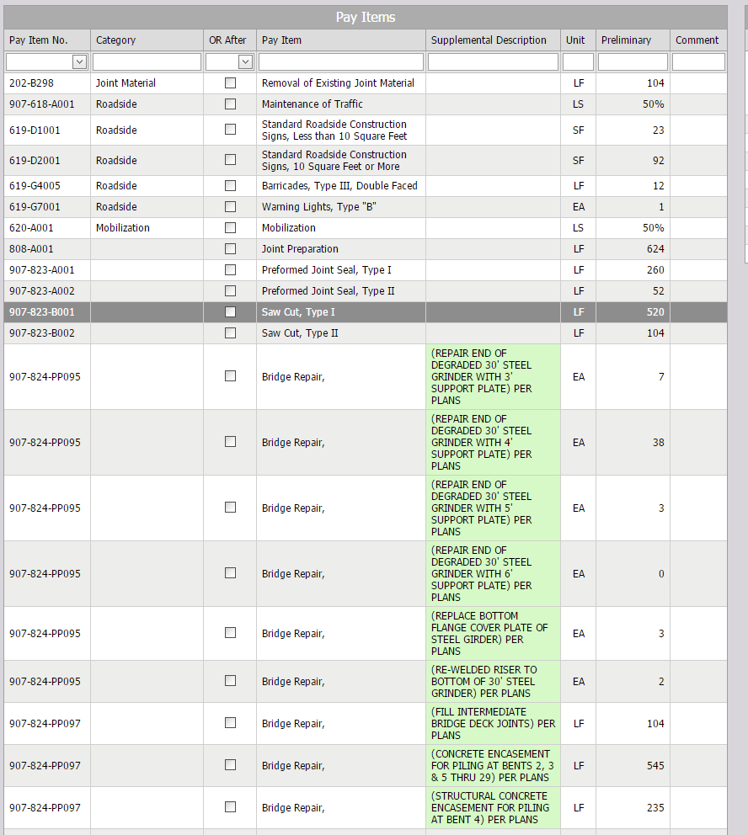
It turns green to indicate changes have been made until save is pressed.

Step 5: Adding Comments
Now that all items have been altered/added any necessary comments can be added. In this example there are no comments but we will create some for practicing reasons.

Add Comment
 To add comments to a worksheet, start by pressing the add button above the comments section. A popup appears where the comment can be entered.
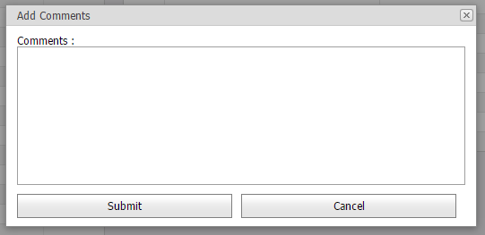
Once the comment is finished, press the submit button. The comment is now added to the comments section of the worksheet.

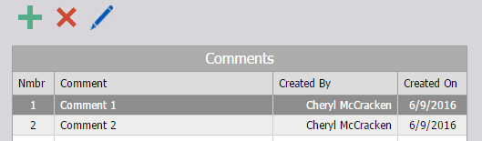
Once a comment has been entered into the section then those comments can be related to a pay items. By clicking in the comment box at the end of the pay item row a drop down appears allowing for the selection of comment numbers.
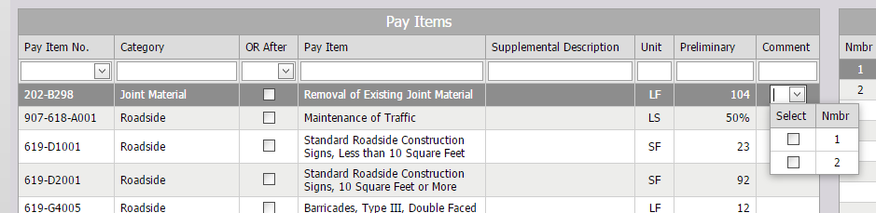

As many comments as needed can be associated to each pay item.
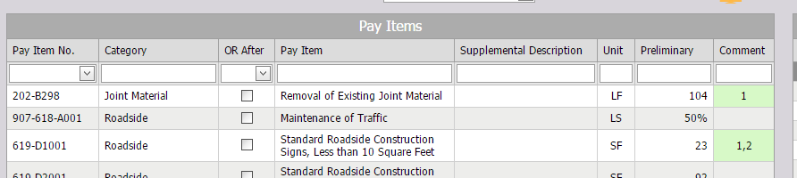
The boxes will remain green until the save button has been pressed. 

Altering Comments
 If a previous comment entered needs to be changed the option exists for the user to click the edit comment button and alter the pre-existing comment as needed. The comment number, creator and create date cannot be altered.

Deleting Comments
To remove a comment. Highlight the comment in the comments section and press the delete button. A prompt will display confirming this deletion. Once accepted, the comment is removed from the comments section as well as the drop down selection under the comments column of the pay items.

If the comment is already being used in the comment column of the pay items, a message will display indicating that the message cannot be deleted.
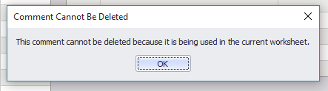

The only comments that you can delete or edit are ones you create yourself. If the comment does not belong to you, then the delete and edit button become unavailable.

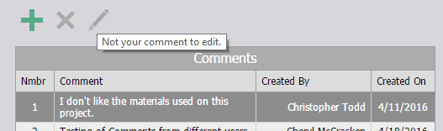

Step 6: Associating Second Project to Worksheet
At this point, contact your admin to have them associate the next project to this worksheet. Once that is completed it can be access through the Pay Items staging area by selecting the dropdown next to “Project Number” and selecting the second project. As you can see all the information that was previously entered, besides Preliminary amounts, have been generated for that project.
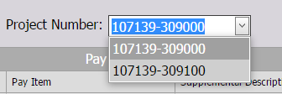

Step 7: Enter Information for Second Project
Now that the project exists, I will go in and populate the amounts for each item on the second project. This is done the same way as before.
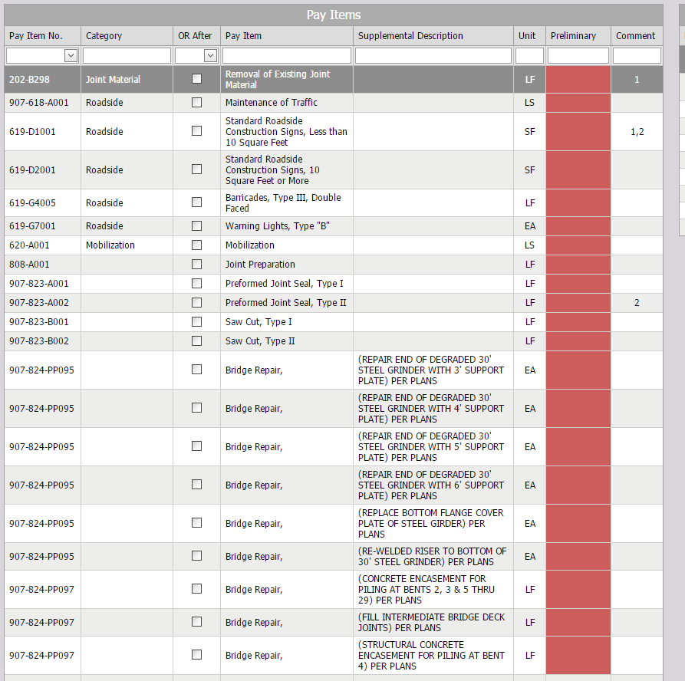

Step 8: Checking In and Submitting the Worksheet

Now that everything has been entered for this worksheet I am going to check in the worksheet by clicking on the green Check In icon.
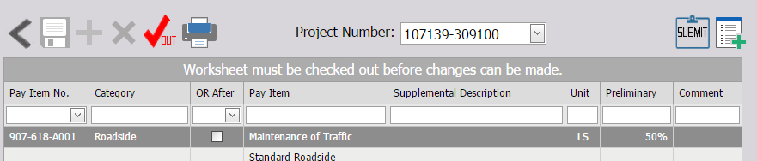

And now I am going to submit the worksheet by pressing the submit button the right. A prompt displays confirming this action.
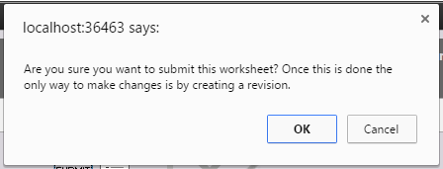

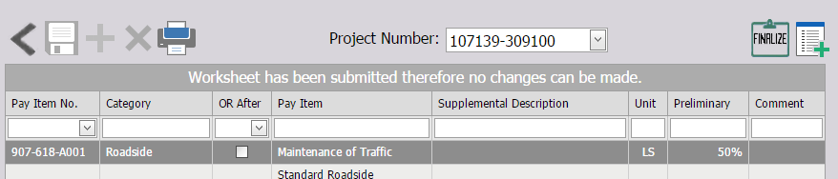

Step 9: Generating the Worksheet
Pressing the “Print” button starts the process of printing the worksheet which can be done at any time.  A prompt will display allowing for the entry of needed information before the worksheet can generated.

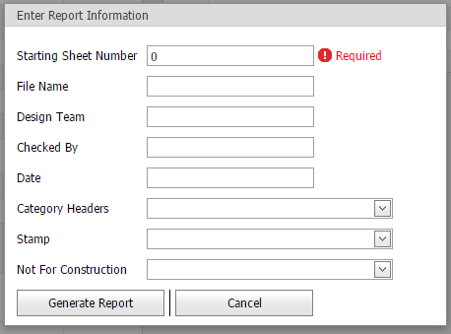
Starting Sheet Number This is required and is the starting number of the worksheet
File Name, Design Team, Checked By and Date are all self-explanatory.
Select Category Headers This allows you to select which Category headers entered will be displayed. If they header is not selected no title will appear above the group. In this case, there are no headers displayed so we will leave this blank.
Stamp This allows a revision stamp to be placed on the worksheet if necessary.
Not For Construction This allows either the MDOT logo or the “NOT FOR CONSTRUCTION” logo to be placed on the worksheet.
In this case we populate the information like this:
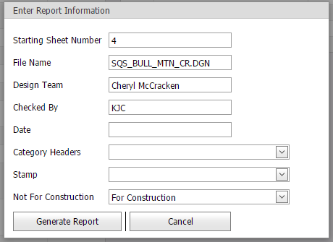

Pressing “Generate Report” will cause the worksheet to display as follows:
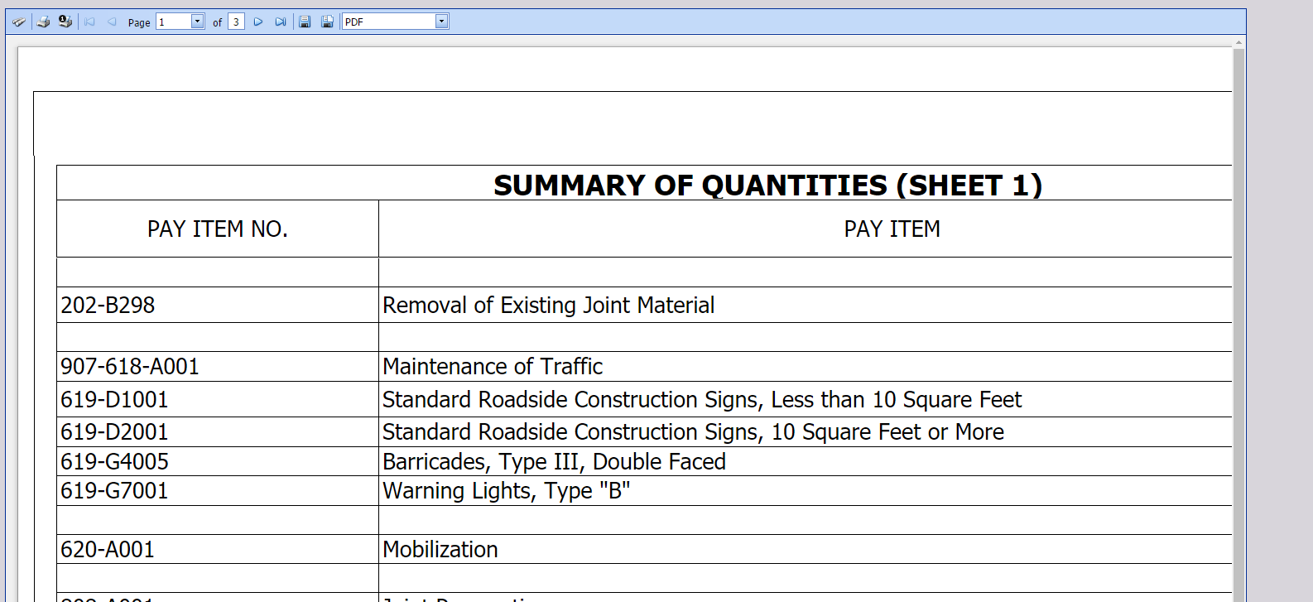

I found that an easier way to view it is to press the PDF button in the viewer:
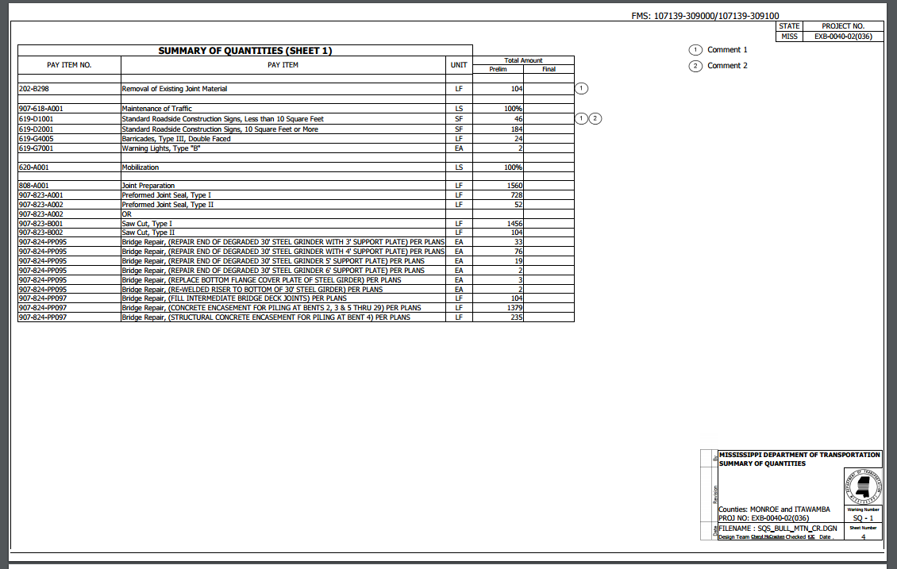
In this case there are three pages.
- Totals of items for both projects
- Items for Project 107139-309000
- Items for Project 107139-309100

If it is later determined that revisions are needed they can be made at this time.

Step 10: Revising Worksheet
To revise a worksheet, select SQS Worksheet in the Menu Bar and select “Revised Worksheets” for your division

This page will display all worksheets that have been submitted and can be revised.
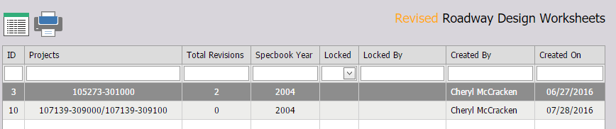
Double click on the worksheet needing revision. If any previous revisions existed for this worksheet they would display here.
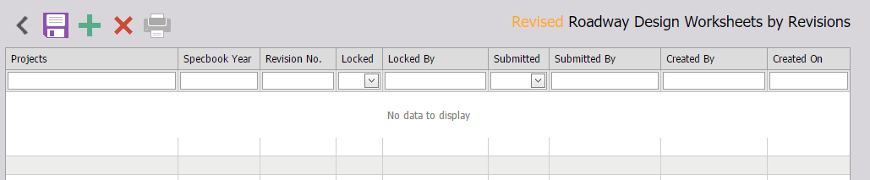

Step 11: Create New Revision
To create a new revision press the “Add” button. A prompt displays to confirm this revision.

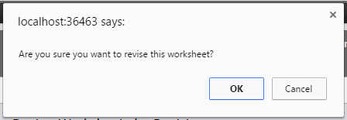

The staging area is pre-populated with all pre-existing pay items and their information.
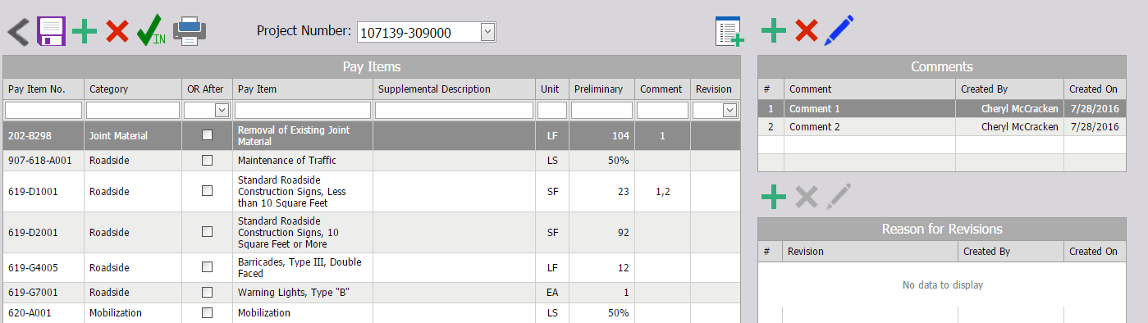

Step 12: Revising Items
Once staging has been completed any item within this area can be altered except for Pay Item No. and Unit. If any information is changed then a revision number is populated in the “Revision” column based upon the revision number of the worksheet.

In this case the following changes colored in green have been made to the worksheet.
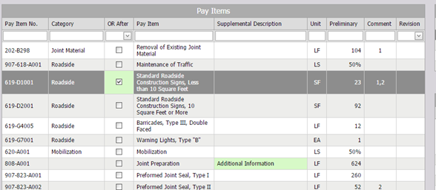

Once save is pressed the revision number of 1 appears in the 2 rows under the revision column.
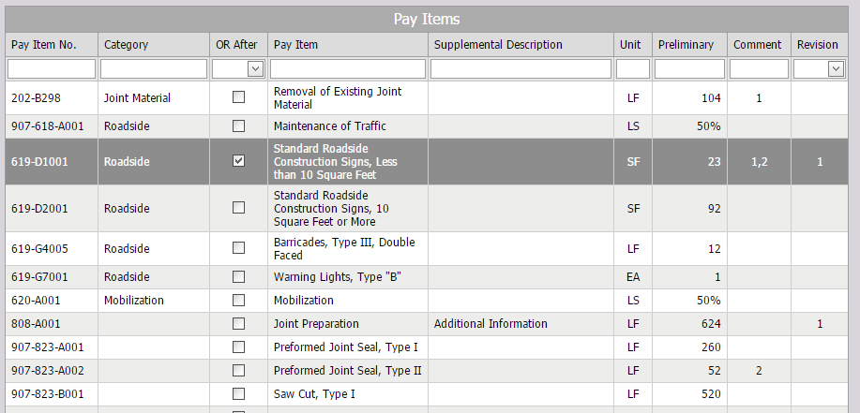

Step 13: Adding Reason for Revision
If desired at this time a reason for the revision can be added.

Adding Revision Reason
 Pressing the add revision button displays a popup that allows for the entering of the reason of the revision.
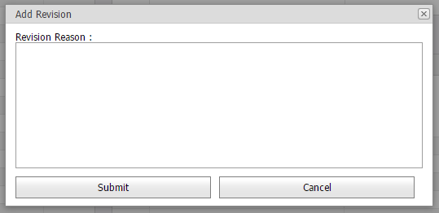

Once a reason has been entered pressing submit will add it to the worksheet.
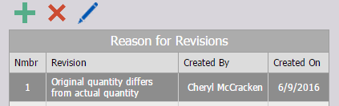

Altering Revisions
 If a previous revision entered needs to be changed the option exists for the user to click the edit revision button and alter the pre-existing revision as needed. The revision number, creator and create date cannot be altered.

Deleting Revision
 To remove a revision. Highlight the revision in the revisions section and press the delete button. A prompt will display confirming this deletion. Once accepted, the revision is removed from the revisions section as well as the drop down selection under the revisions column of the pay items. The only revisions that you can delete or edit are ones you create yourself. If the revision does not belong to you, then the delete and edit button become unavailable.

Once all the revisions have been completed the worksheet can be unlocked and submitted just like before. (See Above).

Step 13: Populating Precon
 Now that all of my changes are made I feel it is time to populate Precon. Populating Precon can be done at any time during the process of creating a worksheet. To populate Precon, I press the populate button and wait. This process could take up to several minutes depending on how many items are being pushed into Precon.
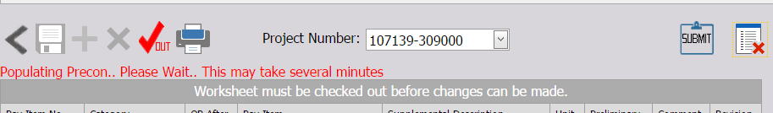
If any items exist that prevent this process from completing an error message will appear:
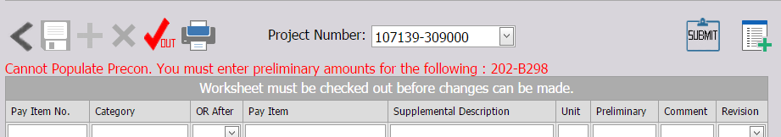
If any items are changed after the initial push to Precon it can be updated by pressing the button again.
If items are accidently added and need to be removed you must contact an admin who has access to removing these items.

Step 14: Finalizing Worksheet
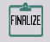 After all revisions (if any are needed) have been created the worksheet can then be finalized.
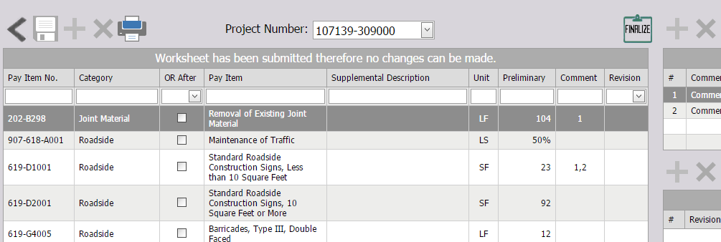

A prompt will display to confirm this finalization.
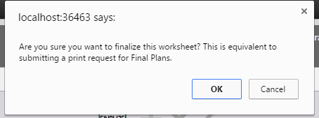

Once confirmed the worksheet becomes locked down and no more alterations or revisions can be made for that worksheet.
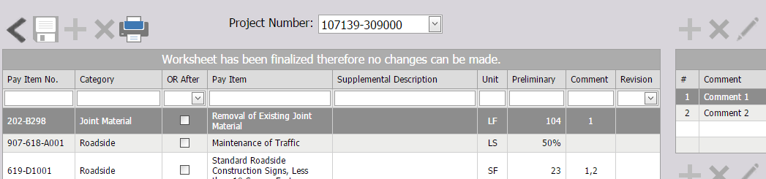

The process of generating an SQS Worksheet is now completed.

